Isaiah Narisma

Professor Underhill

MIS 484-6 (01) 42896

14 December, 2020

AWS Terraform Provisioning

So this attempt of Terraform provisioning I was doing initially in AWS, and I was able to complete all of the steps needed until the section where we needed to enter `terraform init` and then I would get a fatal error.

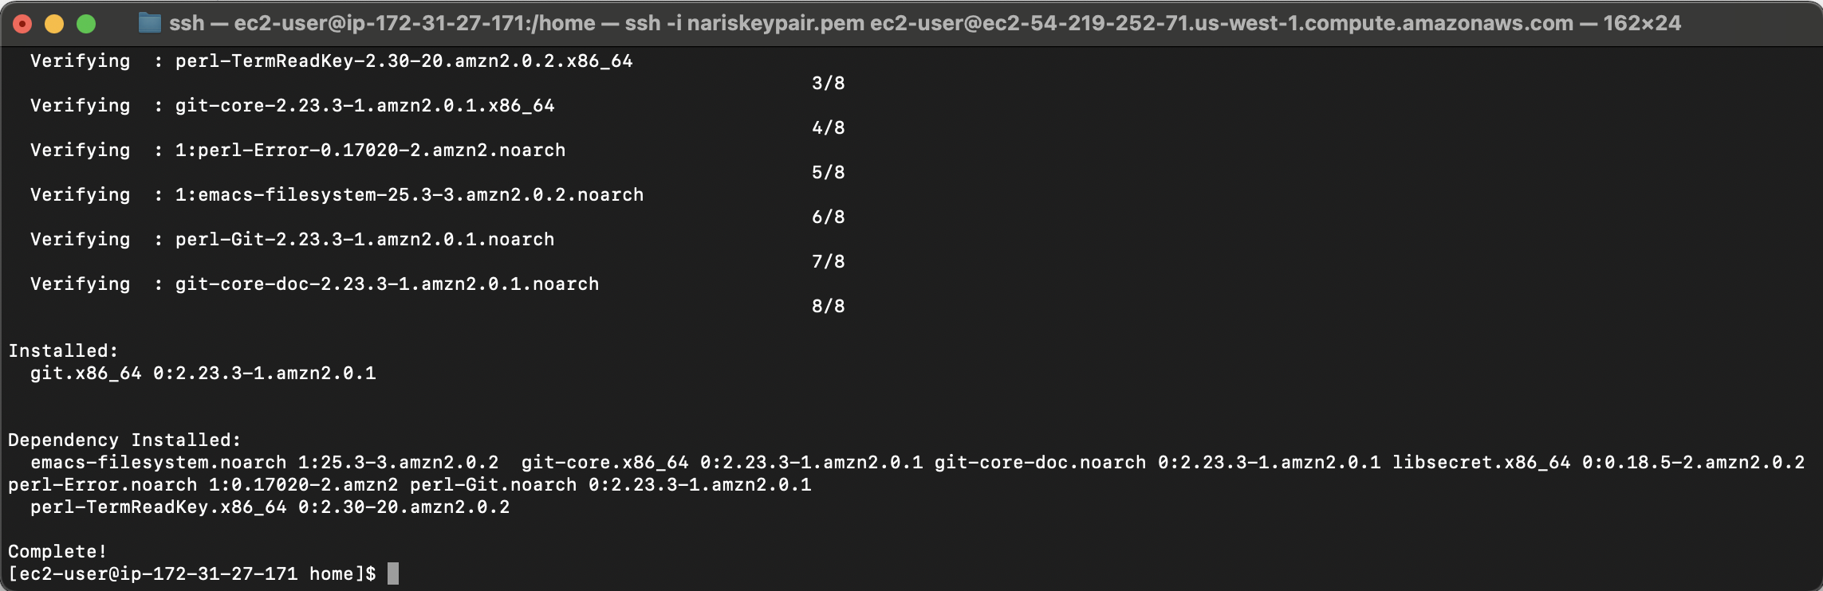

Install git on aws ec2

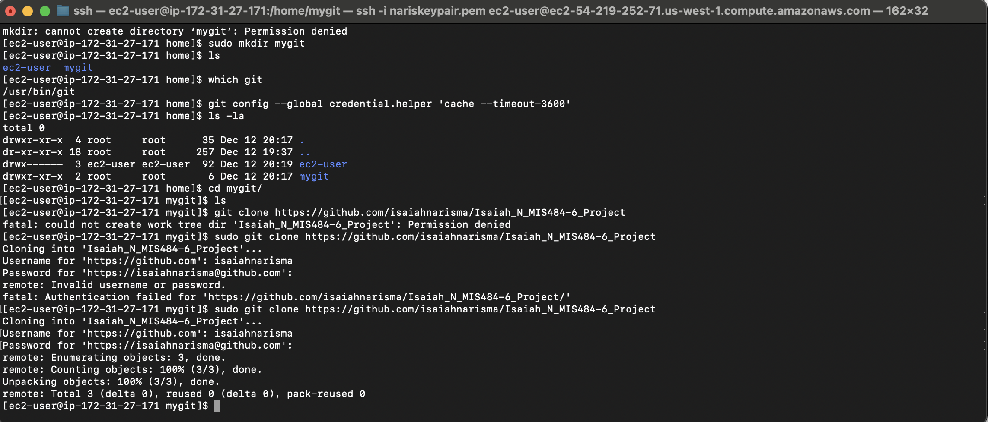

Git clone project

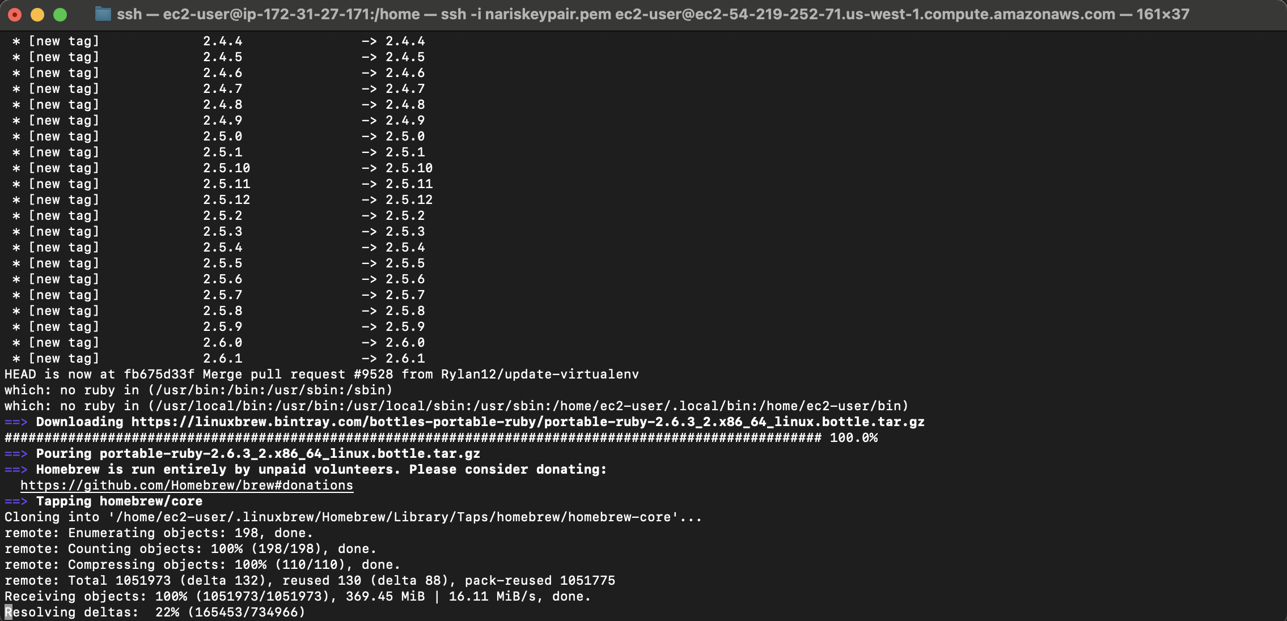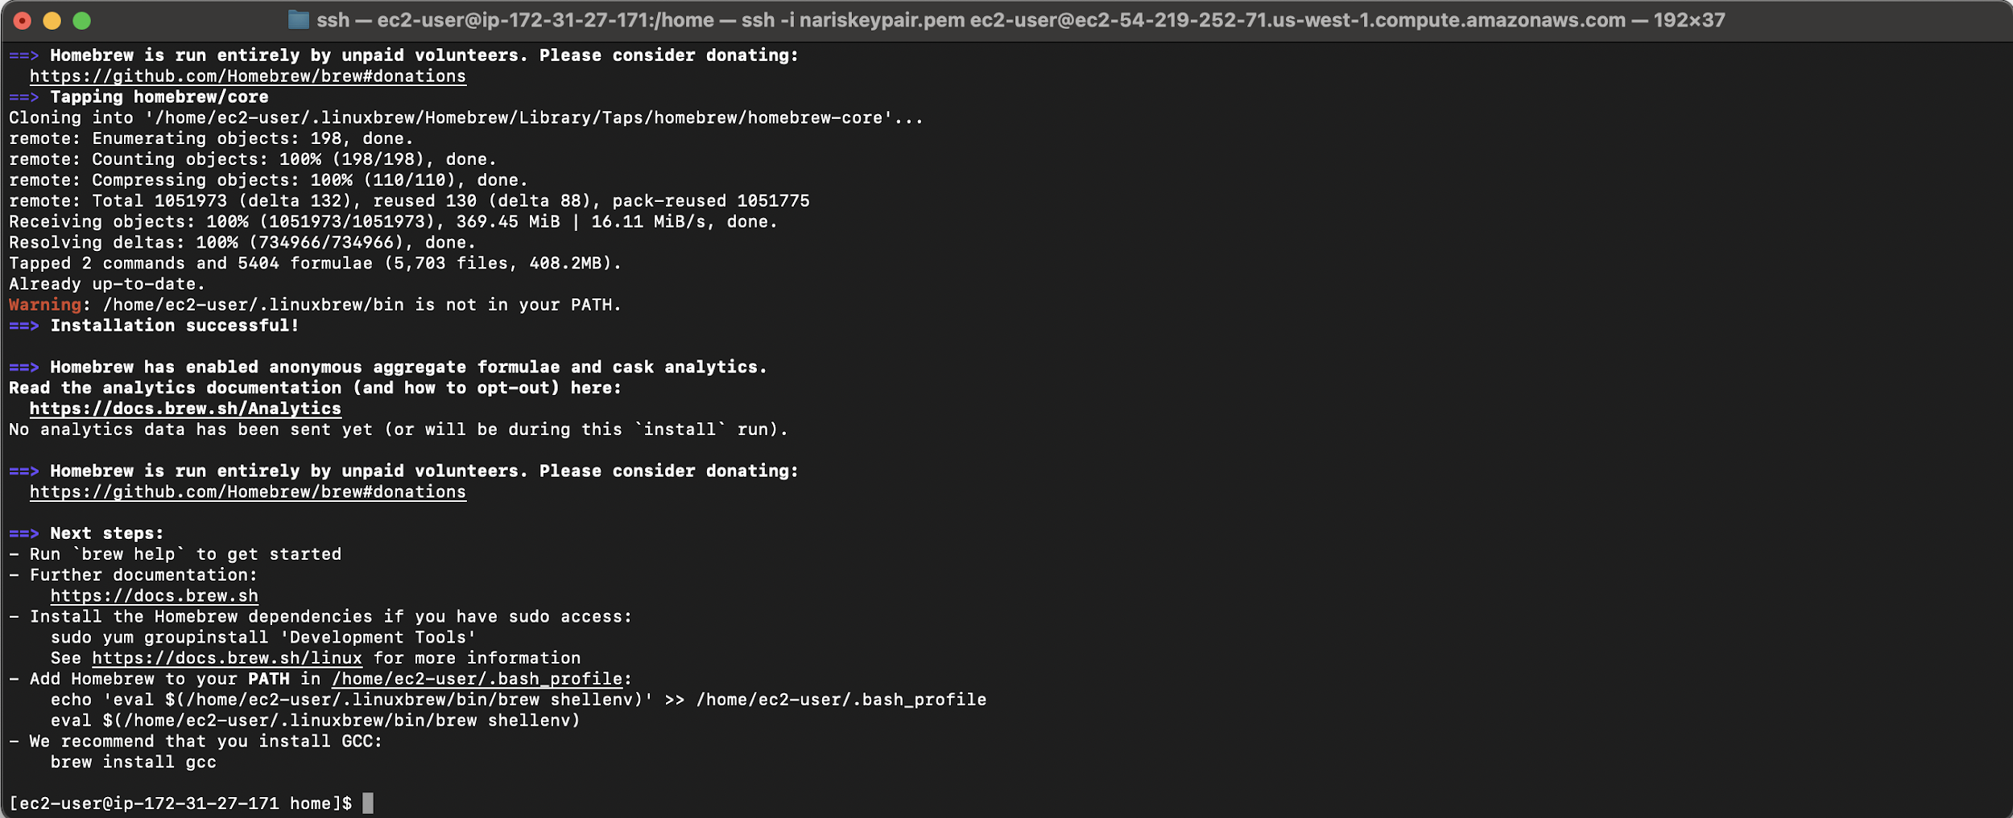

Install Homebrew in AWS EC2

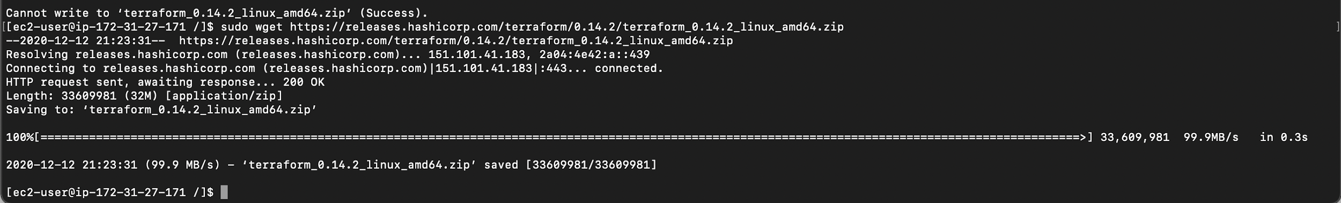

Download Terraform

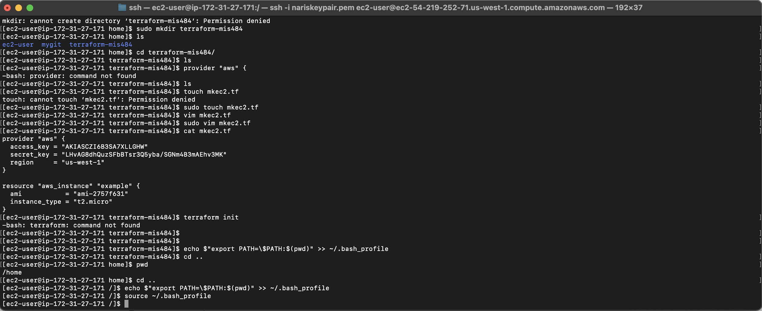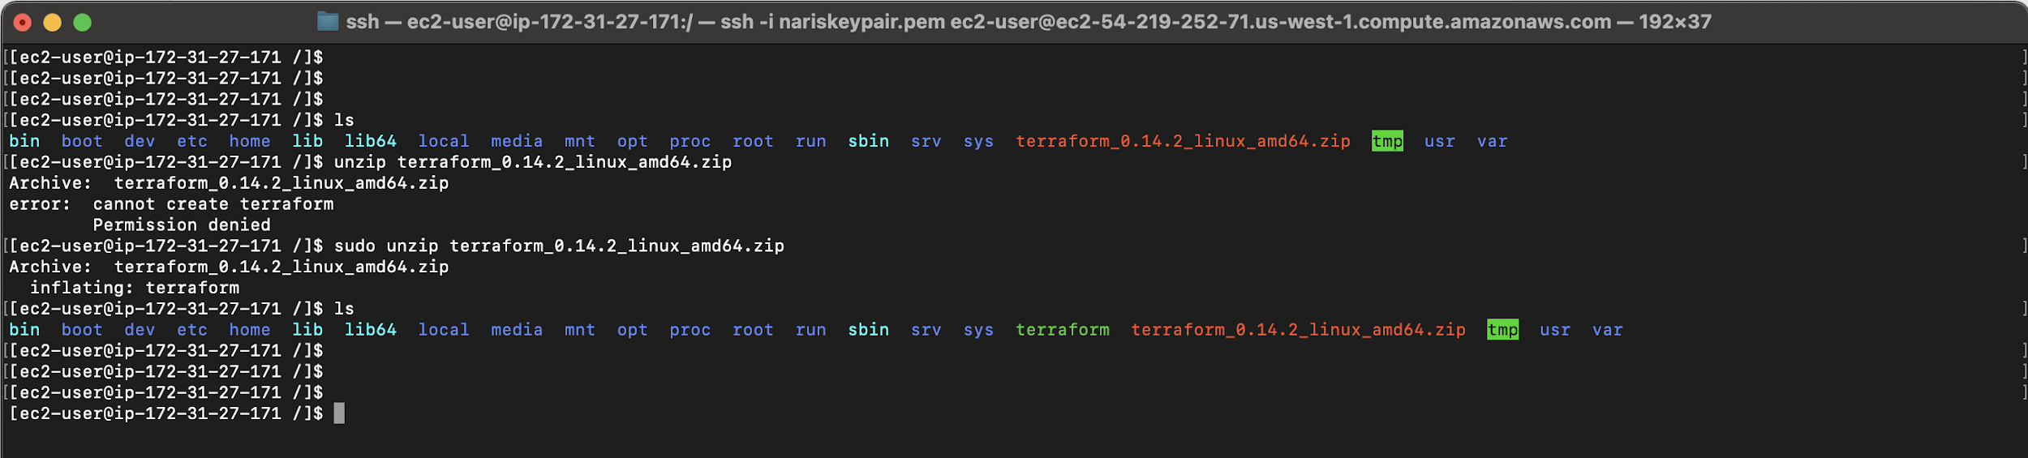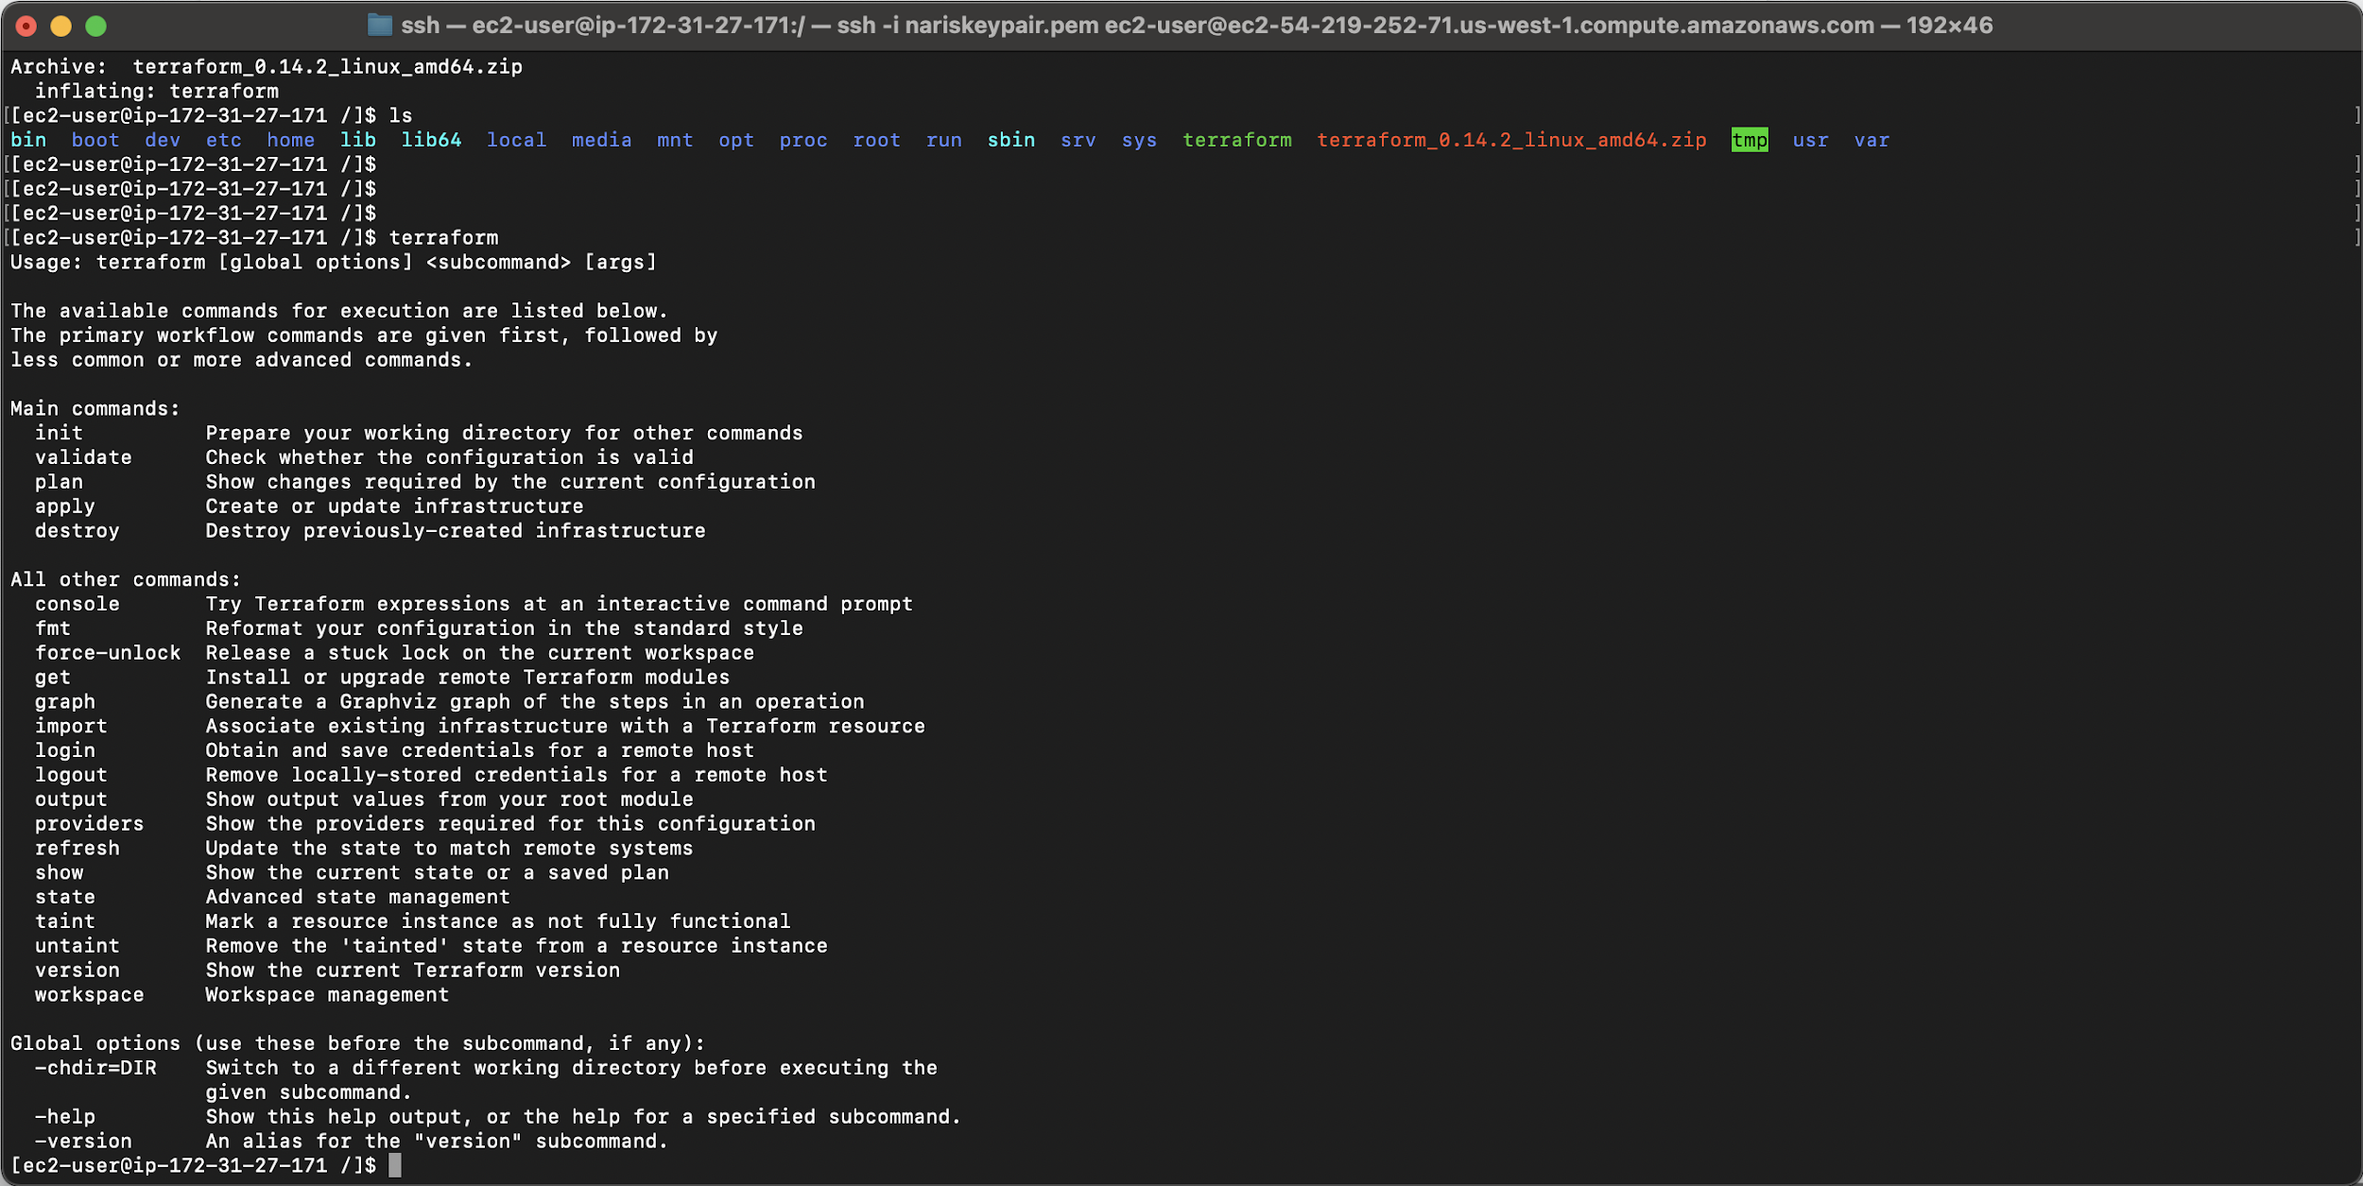

Install terraform and configure it to change the pathing to make `terraform init` command work

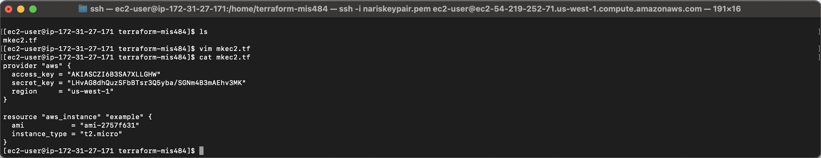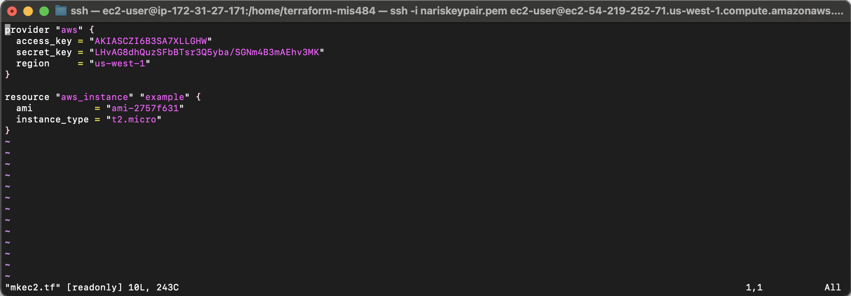

Terraform .tf script to provision an EC2 instance in AWS

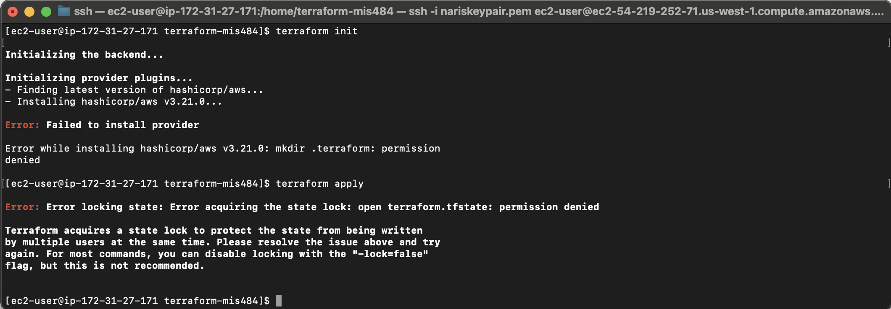

Hit a road bump, failed to install provider citing `permission denied` so I tried to do this from my aws root user, I tried to attach more dev policies from the IAM configurations, I tried to sudo it didn’t work because its an executable.

Found out that this is the reason why we should not use AWS educate accounts with this

project, because this is a limitation with the AWS provider and Terraform. Moved all of my applications off of AWS and on to GCP.

At this point I was running out of time and I needed to simply just switch to GCP and redownload Git, redownload wget, and redownload unzip to install homebrew and terraform. The rest of my provisioning is in the google provisioning section of this project included.